MT. HARMONY ELEMENTARY CHORUS SCHEDULE
SEPTEMBER 2023

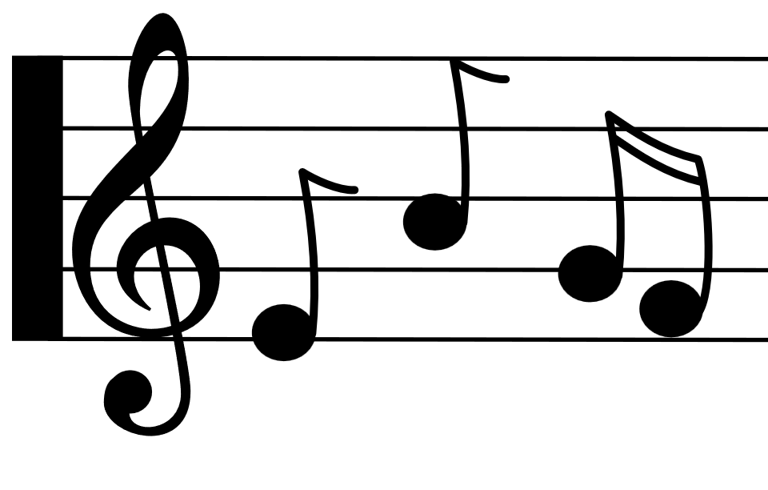
Monday | Tuesday | Wednesday | Thursday | Friday
1st
^{E Day}

4th  ^{NO SCHOOL} | 5th  ^{A Day} | 6th  ^{B Day} | 7th  ^{C Day} | 8th  D Day
11th  ^{E Day} | 12th  ^{A Day} | 13th  ^{B Day}  2- Hour Delay | 14th  ^{C Day} | 15th  D Day
18th  ^{E Day} | 19th  ^{A Day} | 20th  ^{B Day}  ^{CHORUS BEGINS!}  3rd Grade:  2:30 – 3:15 | 21st  ^{C Day}  ^{CHORUS BEGINS!}  4th Grade:  2:30 – 3:15 | 22nd  D Day  ^{CHORUS BEGINS!}  5th Grade:  2:30 – 3:15
25th  ^{E Day} | 26th  ^{A Day} | 27th  ^{B Day}  3rd Grade:  2:30 – 3:15 | 28th  ^{C Day}  2- Hour Early  Dismissal  NO CHORUS | 29th  ^{NO SCHOOL}

