MT. HARMONY ELEMENTARY CHORUS SCHEDULE
NOVEMBER 2023

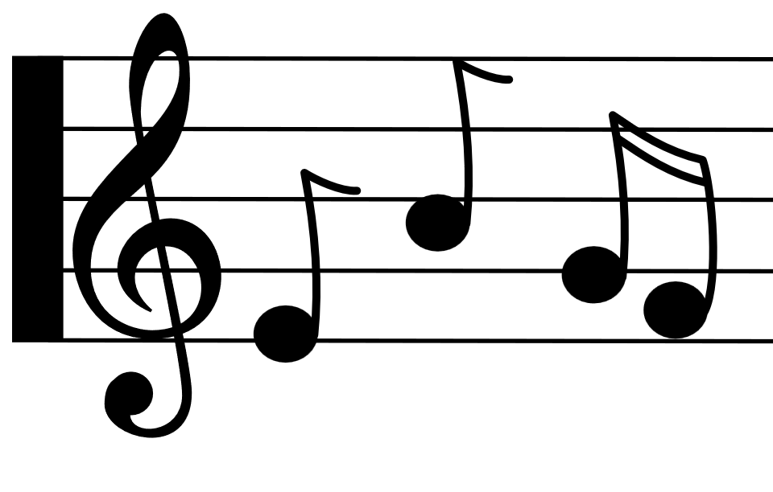
Monday | Tuesday | Wednesday | Thursday | Friday
 |  | 1st  ^{E Day} | 2nd  ^{A Day} | 3rd  ^{B Day}  2 Hour Early  NO CHORUS
6th  ^{C Day}  4th Grade:  2:30 – 3:15 | 7th  ^{D Day}  5th Grade:  2:30 – 3:15 | 8th  ^{E Day} | 9th  ^{A Day} | 10th  No School  For Students
13th  ^{B Day}  3rd Grade:  2:30 – 3:15 | 14th  ^{C Day}  4th Grade:  2:30 – 3:15 | 15th  ^{D Day}  5th Grade:  2:30 – 3:15 | 16th  ^{E Day} | 17th  ^{A Day}
20th  ^{B Day}  3rd Grade:  2:30 – 3:15 | 21st  ^{C Day}  4th Grade:  2:30 – 3:15 | 22nd  NO SCHOOL | 23rd  NO SCHOOL | 24th  NO SCHOOL
27th  D Day  5th Grade:  2:30 – 3:15 | 28th  E Day | 29th  ^{A Day} | 30th  ^{B Day}  3rd Grade:  2:30 – 3:15

