MT. HARMONY ELEMENTARY CHORUS SCHEDULE
MARCH 2024

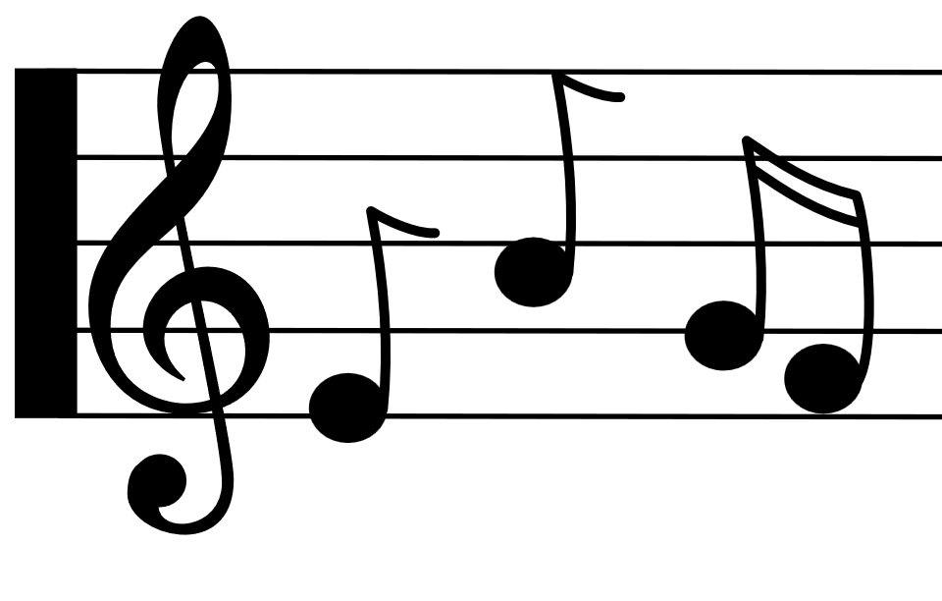
Monday | Tuesday | Wednesday | Thursday | Friday
1st
D Day

5th Grade:
2:30 – 3:15

4th  B Day  3rd Grade:  2:30 – 3:15 | 5th  C Day  4th Grade:  2:30 – 3:15 | 6th  D Day  NO CHORUS | 7th  ^{E Day} | 8th  A Day
11th  B Day  3rd Grade:  2:30 – 3:15 | 12th  C Day  4th Grade:  2:30 – 3:15 | 13th  D Day  5th Grade:  2:30 – 3:15 | 14th  ^{E Day} | 15th  A Day
18th  B Day  3rd Grade:  2:30 – 3:15 | 19th  C Day  NO CHORUS | 20th  D Day  5th Grade:  2:30 – 3:15 | 21st  ^{E Day} | 22nd  A Day
25th  NO SCHOOL  SPRING BREAK | 26th  NO SCHOOL  SPRING BREAK | 27th  NO SCHOOL  SPRING BREAK | 28th  NO SCHOOL  SPRING BREAK | 29th  NO SCHOOL  SPRING BREAK

