MT. HARMONY ELEMENTARY CHORUS SCHEDULE
JANUARY 2024

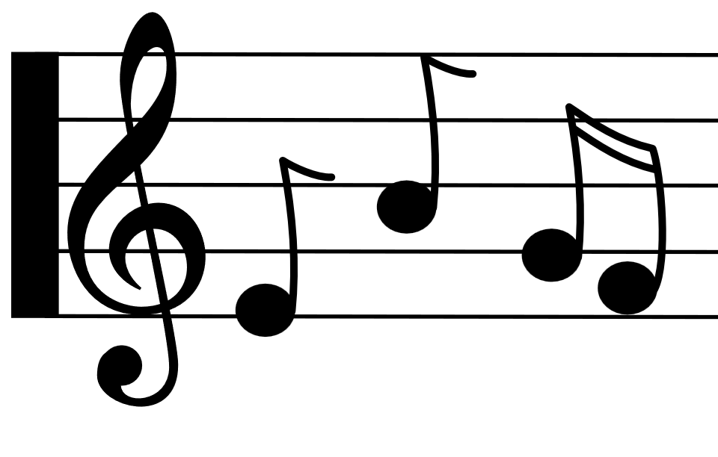
Monday | Tuesday | Wednesday | Thursday | Friday
1st  NO SCHOOL | 2nd  NO SCHOOL | 3rd  ^{C Day} | 4th  D Day | 5th  E Day
8th  ^{A Day} | 9th  B Day | 10th  ^{C Day} | 11th  D Day | 12th  E Day
15th  NO SCHOOL  MLK JR. DAY | 16th  ^{A Day} | 17th  B Day  3rd Grade:  2:30 – 3:15 | 18th  ^{C Day}  4th Grade:  2:30 – 3:15 | 19th  D Day  5th Grade:  2:30 – 3:15
22nd  E Day  2 – HOUR  DELAY | 23rd  ^{A Day} | 24th  B Day  3rd Grade:  2:30 – 3:15 | 25th  ^{C Day}  4th Grade:  2:30 – 3:15 | 26th  D Day  5th Grade:  2:30 – 3:15
29th  E Day | 30th  ^{A Day} | 31st  B Day  3rd Grade:  2:30 – 3:15

