MT. HARMONY ELEMENTARY CHORUS SCHEDULE
APRIL 2024

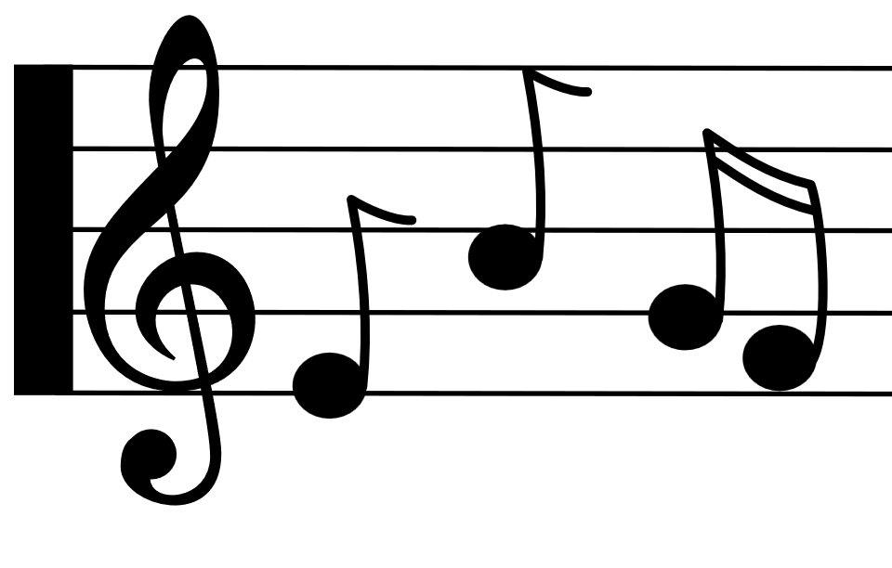
Monday | Tuesday | Wednesday | Thursday | Friday
1st  NO SCHOOL  SPRING BREAK | 2nd  NO SCHOOL  FOR STUDENTS | 3rd  B Day  3rd Grade:  2:30 – 3:15 | 4th  ^{C Day}  4th Grade:  2:30 – 3:15 | 5th  ^{D Day}  5th Grade:  2:30 – 3:15
8th  E Day  2-Hour Delay | 9th  A Day | 10th  B Day  3rd Grade:  2:30 – 3:15 | 11th  ^{C Day}  4th Grade:  2:30 – 3:15 | 12th  ^{D Day}  5th Grade:  2:30 – 3:15
15th  E Day | 16th  A Day | 17th  B Day  3rd Grade:  2:30 – 3:15 | 18th  ^{C Day}  4th Grade:  2:30 – 3:15 | 19th  ^{D Day}  5th Grade:  2:30 – 3:15  3rd Grade Chorus Concert  6:45pm
22nd  E Day | 23rd  A Day | 24th  B Day | 25th  ^{C Day}  4th Grade:  2:30 – 3:15 | 26th  ^{D Day}  5th Grade:  2:30 – 3:15
29th  E Day | 30th  A Day

